**Terraform Installation on Linux:**

Step 1: go to https://www.terraform.io/downloads.html

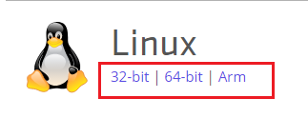

Step 2: copy 32-bit | 64-bit | Arm url

https://releases.hashicorp.com/terraform/0.9.8/terraform_0.9.8_linux_amd64.zip

Step 3: Download the zip file by using **wget** comand

wget https://releases.hashicorp.com/terraform/0.9.8/terraform_0.9.8_linux_amd64.zip



Step 4: Verify the downloaded zip file



Step 5: **unzip** the terraform_0.9.8_linux_amd64.zip file to /usr/bin

unzip terraform_0.9.8_linux_amd64.zip -d /usr/bin



Note: use **sudo** command if you’re not in root user

Step 6: Verify unzipped terraform file in **/usr/bin/terraform**

ls /usr/bin/terraform



Step 7: Verify terraform weather terraform command is working or not using **terraform** command

terraform -v



**Congratulations. installation has been completed.**